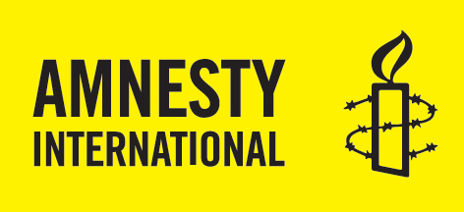
Get involved with Amnesty International Australia
If you would like to become involved with Amnesty International or if you’d like to find out more information, please leave your details below and we’ll be in contact soon.

NAME | EMAIL | PHONE | POSTCODE | HOW YOU HEARD ABOUT THE EVENT | WOULD YOU LIKE TO CONTINUE GETTING INVOLVED?
 |  |  |  |  | LOCAL GROUPS | MAILING LIST
Andy Scott | Andy.scott@amnesty.org.au | 0431137428 | Sherwood

Privacy and Security: Amnesty International Australia is committed to protecting your privacy. The information you provide will remain private and will only be used for the purposes outlined here. Amnesty International Australia will not share, sell, lend or rent your personal information to third parties.

