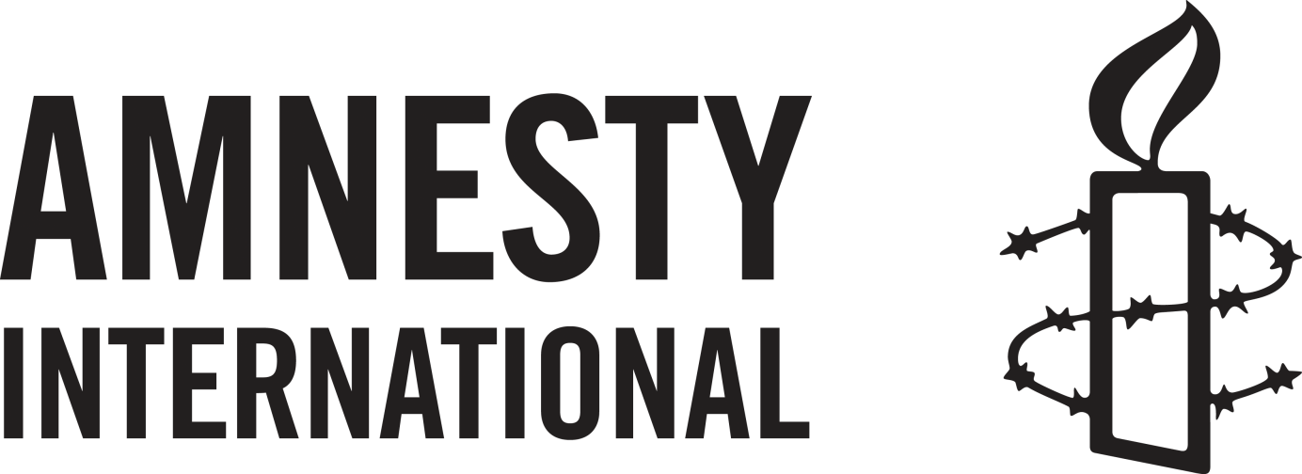

HUMAN RIGHTS INNOVATION FUND

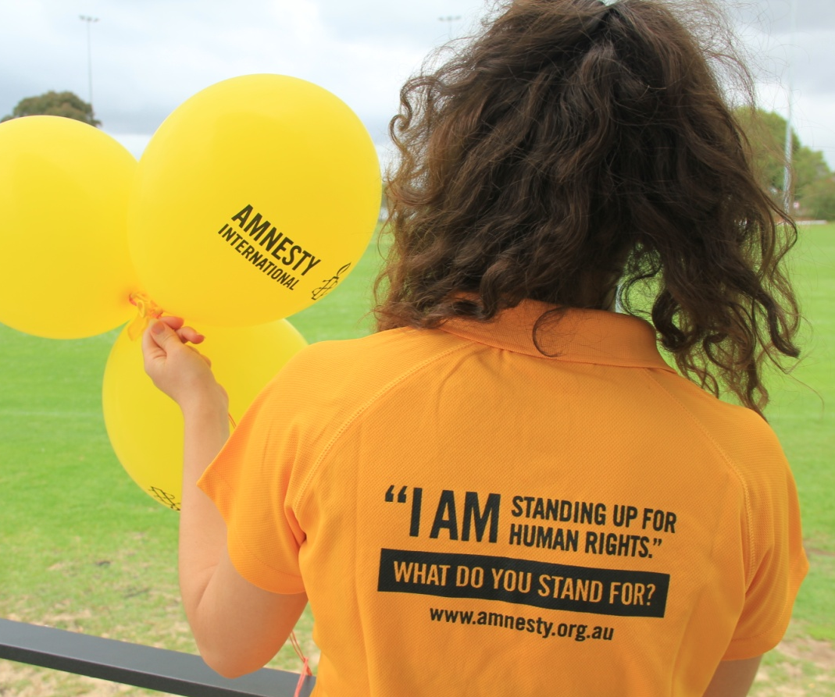

Amnesty International Australia
Locked Bag 23, Broadway, NSW 2007
ABN 64 002 806 233
November 2017

HUMAN RIGHTS INNOVATION FUND - APPLICATION GUIDELINES

What is the Human Rights Innovation Fund?

Amnesty International Australia has established a Human Rights Innovation Fund to support innovative and creative initiatives which promote and defend human rights in Australia.

Funding is available to individuals, action groups, community groups or networks and organisations from any Australian State or Territory.

What are the Fund’s Objectives?

Amnesty’s Human Rights Innovation Fund is for activities which will have a demonstrable human rights impact in Australia. It is an important part of our commitment to:

- fostering grassroots community activism;
- engage and empower a diversity of people to build networks and promote the growth of a human rights constituency;
- acknowledging the initiatives and endeavours of the human rights movement; and
- developing partnerships with other organisations.

The Human Rights Innovation Fund also has a special category for projects which will assist our campaign to end the overrespresentation of Australian Indigenous young people in detention within a generation. See page 9 for details.

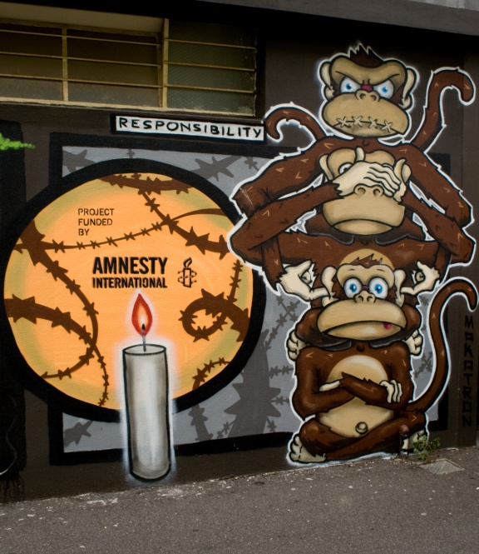
Examples of initiatives that the Fund may support include:

innovative programs that educate and
mobilise the public around human rights
issues

stimulating Amnesty supporter activity with
an engaging form of activism

human rights awareness raising activity
and/or outreach to new audiences

Cycling for Freedom

Examples of possible project ideas include:

(These are a small sample only – we encourage you to think outside the square!)

- Diversity education - through storytelling or a participative activity

- Racism prevention - using social media training to empower young people to speak out

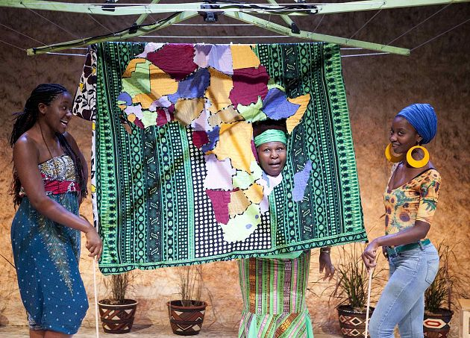
- Activism training – seminars/events

- Awareness raising through speaker tours – a globally-recognised human rights activist; a Human Rights Defender

- A virtual network focussing on a human rights issue – human rights and climate change

- Mobilising activists –festivals, displays, concerts, exhibitions, sports events

- Networking with human rights organisations for a particular outcome - Protecting Individuals at Risk
The Baulkham Hills Ladies African Troupe – a theatre work addressing the effects of trauma and what it means to make a new life in a new country

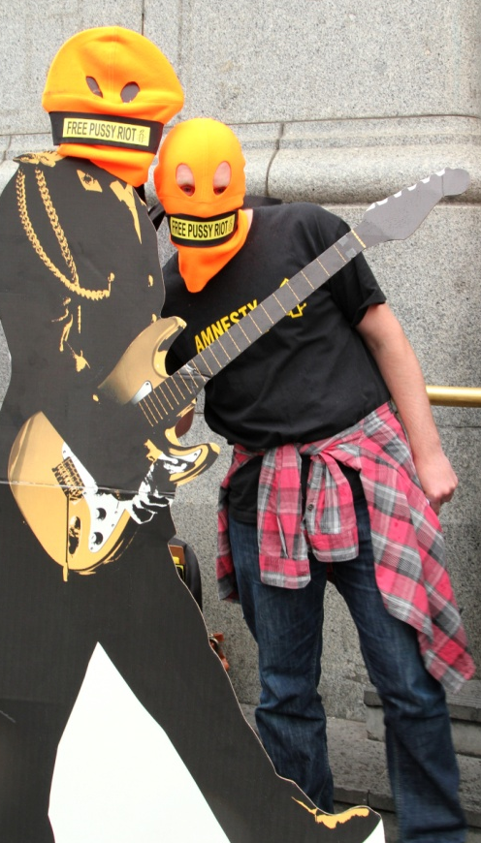
Initiatives that have previously received funds include:

- Translating the universal Declaration of Human Rights into the Pintupi-Luritja Aboriginal language for schools, youth programs, police and regional land councils in Central Australia.

- A documentary film providing a visceral insight into the terrible and frightening journey of an asylum seeker from detention in Indonesia to Australia.

- A youth arts festival to creatively celebrate human rights and the arts.

- Political theatre workshops to empower and engage young people, enabling them to develop and utilise theatre for social change.

- Infrastructure support for an exciting and innovative international human rights program – a living library, with people rather than books, who tell their stories to school children or individuals at public events and festivals.

- A human rights football festival to raise awareness of human rights to disadvantaged and diverse youth and their community.

Amnesty activists drawing attention to the imprisonment of Pussy Riot in Russia.

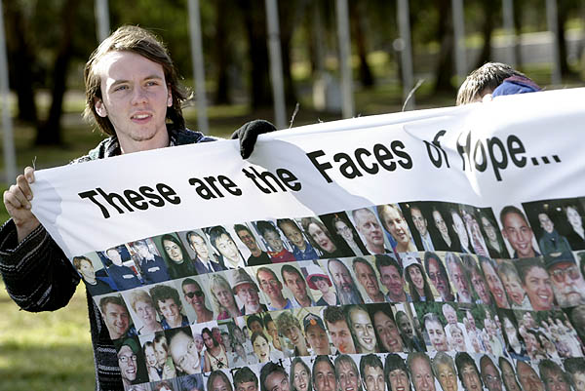

There are many examples, and you can read more about previous Human Rights Innovation Fund recipients on our web site: http://www.amnesty.org.au/about/comments/21837

How are applications made?

The attached application form must be emailed to hrif@amnesty.org.au by the 28th February 2018. We are in the midst of reviewing the dates for the rest of the year so stay tuned for more information.

What are the funding criteria?

Projects must have the potential to advance one or more of the fund’s objectives:

- Have a demonstrable human rights impact.
- foster grassroots community activism;
- engage and empowering a diversity of people to build networks and promote the growth of a human rights constituency;
- acknowledge the initiatives and endeavours of the human rights movement; and
- develop partnerships with other organisations

- Projects must be undertaken by Australian-based individuals, groups, organisations etc. and must be for work in Australia.

- Projects must be completed within one year of the project’s start date.

- If the project requires resources (time, labour, equipment, advice, support etc.) from any other person, group or organisation, the proposer of the project must get ‘third party endorsement’ from that individual, group or organisation if your proposal is successful. To accompany your application, you will need a letter of ‘in principle’ support only – it does not need to be a concrete commitment.

Amnesty International Australia cannot pay wages. If wages form part of your project budget, you will need to be an employer or the person(s) to be paid will need to have an ABN.

- If the project raises any funds directly, all funds raised must be remitted to Amnesty International for its general use.

- No single project will be awarded more than $8,000.

- Smaller projects, even very small, are welcome.

- Successful applicants will be required to submit a project evaluation to Amnesty International within two months of the completion of their project.

How are applications assessed?

Proposals will be assessed by the Human Rights Innovation Fund Committee (comprising staff and active Amnesty International supporters) and applicants will be contacted within eight weeks of the closing of each funding round.

More information?

If you would like to discuss your ideas, please contact us via hrif@amnesty.org.au

HUMAN RIGHTS INNOVATION FUND APPLICATION FORM
CONTACT DETAILS
Contact person: |  |  | Email address:
Organisation Name  If applicable |  |  | Phone numbers:
Address
Tell us a bit about yourself/your group/your organisation:
PROJECT DESCRIPTION
Name of proposed project:
Description of the project:
Maximum one page
How is this project innovative and/or creative?

What Amnesty objectives will your project achieve:
List all that are relevant
How will your activity achieve these objectives?
How will you know your project has been successful?

Who will be involved in your activity?

Will the project be in conjunction with another person, group or organisation? If so which who?

Please attach letter(s) indicating ‘in principle’ support for the project

Will the project/event be supported by or accessed by Amnesty International Australia activists?

Please provide the name and contact details of two referees.

When would your project start and end?

PROJECT BUDGET
Amount Requested (Maximum $8,000) |  | $

PLEASE NOTE: Amnesty International Australia cannot pay wages. If wages form part of your project budget, you will need to be an employer or the person(s) to be paid will need to have an ABN.
COSTS  Please provide a breakdown of project costs |  |  | $ AMOUNT

INCOME

Please provide detail of any income that will offset these costs

DECLARATION BY PROPOSER

The information in this application is true and reasonable to the best of my knowledge. I understand that this is an application only and may not result in funding.
Signed: |  | Date:

Print Name:

Please submit your completed application and any attachment by email to hrif@amnesty.org.au by:
28th February

The Human Rights Innovation Fund

and Indigenous Youth Justice campaign

The Report – A Brighter Tomorrow …

In June 2015, Amnesty International Australia launched the report “A Brighter Tomorrow: Keeping Indigenous kids in the community and out of detention in Australia”. Indigenous youth detention in Australia is a national crisis – Indigenous young people are 26 more times more likely to be in detention than non-Indigenous young people. Western Australia detains Indigenous children at 53 times the rate of their non-Indigenous peers.
You can read the report, “A Brighter Tomorrow …” here:
http://www.amnesty.org.au/images/uploads/aus/A_brighter_future_National_report.pdf

Amnesty will be working over the coming years to ensure a brighter tomorrow for Indigenous kids. The report makes comprehensive, practical recommendations to government on how to reduce the rate of Indigenous youth incarceration and make communities safer. It also examines the innovative Indigenous-led prevention and diversion programs that are achieving impressive results.

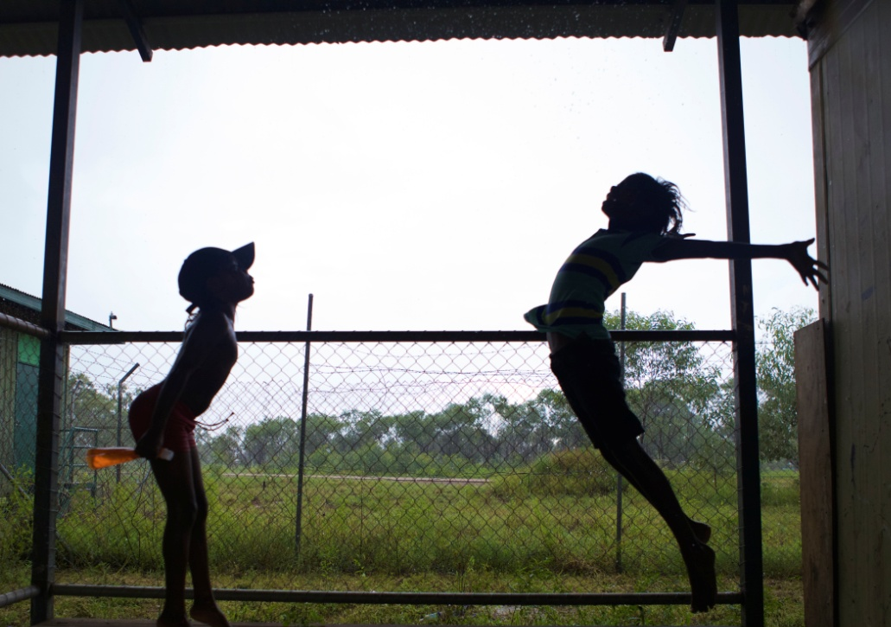

The Campaign – Community is Everything

Amnesty’s Indigenous Youth Justice campaign, Community is Everything, is designed to end the overrepresentation of Indigenous young people in detention within a generation.

The Human Rights Innovation Fund

Between 2015 and 2019, in recognition of the importance of this campaign, Amnesty International Australia will provide at least one grant each year, through the Human Rights Innovation Fund, to Indigenous organisations working to:

- end youth incarceration; and/or

- to support Indigenous individuals/families/communities experiencing youth detention.

Your proposal could involve remote or urban communities, it could complement or be an element of an early intervention, prevention or diversionary program, or it could be an event or activity that supports the campaign. Amnesty encourages Indigenous ‘stakeholders’ to develop creative interesting, positive initiatives that will help keep kids out of detention and in the community where they belong.

Who can apply?

The Human Rights Innovation Fund for Indigenous Youth Justice initiatives is open to Indigenous-led and directed organisations only.

Funding Criteria

- Projects must have a demonstrable human rights impact in that it supports the aim of Amnesty’s Indigenous Youth Justice campaign;

- Projects must be an Indigenous-led and designed initiative;

- Projects must be achievable within the funding available (maximum $8,000);

- Smaller projects, even very small, are very welcome;

- Projects must be completed within one year of the project’s start date;

- Amnesty International Australia cannot pay wages. If wages form part of your project budget, you will need to be an employer or the person(s) to be paid will need to have an ABN;

- Successful applicants will be required to submit a short project report/evaluation within two months of the completion of the project.

How do I apply?

There are four quarterly grant rounds each year. The attached application form must be sent to hrif@amnesty.org.au by the 28th February 2018. We are in the midst of reviewing the dates for the rest of the year so stay tuned for more information.

How are applications assessed?

Proposal will be assessed by the Human Rights Innovation Fund Committee (comprising staff and active Amnesty International supporters) and applicants will be contacted within 8 weeks of the funding round closing.

More information?

If you would like to discuss your ideas, please contact us on the email address above.

HUMAN RIGHTS INNOVATION FUND APPLICATION FORM
INDIGENOUS YOUTH JUSTICE
CONTACT DETAILS
Contact person: |  |  | Email address:
Organisation Name |  |  | Phone numbers:
ABN
Address
Tell us a bit about your organisation:
PROJECT DESCRIPTION
Name of proposed project:
Description of the project:
Maximum one page
What human rights impact will your project achieve:

How will you know your project has been successful?

Who will be involved in your project?

Will the project be in conjunction with another group or organisation? If so which who?

Please attach letter(s) indicating ‘in principle’ support for the project

Please provide the name and contact details of two referees if possible.

When would your project start and end?

PROJECT BUDGET
Amount Requested (Maximum $8,000) |  | $

PLEASE NOTE: Amnesty International Australia cannot pay wages. If wages form part of your project budget, you will need to be an employer or the person(s) to be paid will need to have an ABN.
COSTS  Please provide a breakdown of project costs |  |  | $ AMOUNT

INCOME

Please provide detail of any income that will offset these costs

DECLARATION BY PROPOSER

The information in this application is true and reasonable to the best of my knowledge. I understand that this is an application only and may not result in funding.
Signed: |  | Date:

Print Name:

Please submit your completed application and any attachment by email to
hrif@amnesty.org.au by:
28th February

